SmartCare v0.3 - Domain Model Workbook
Week 6 student resource

Requirement-to-Concept Trace
Requirement | Concept | State/behaviour | Decision
FR-01 | Patient | State: patient information; behaviour: store information. | Keep Patient as a class.
FR-02 | Patient | Behvaiour: search/retrieve patient information. | Keep Patient as a class.
FR-03 | Appointment | State: appointment information. | Keep Appointment as a class.
FR-04 | Appointment | Behaviour – detect duplicate bookings. | Keep Appointment as a class.
FR-05 | Appointment | State: appointment status. | Keep status as an Appointment attribute.
FR-06 | Appointment | State/behaviour: retain appointment history. | Keep history with Appointment.
FR-07 | Appointment | Behaviour: view appointment history. | Keep Appointment as a class.
FR-08 | Practitioner | State: practitioner information. | Keep Practitioner as a class.
FR-09 | Appointment | Behaviour: update appointment status. | Keep Appointment as a class.
FR-10 | Patient | Behaviour: update patient information (provisional). | Keep Patient class; update behaviour requires validation.

CRC Cards

Patient
Responsibilities | Collaborators
Store patient information; allow information to be searched/retrieved. | Appointment
Allow patient information to be updated (provisional). | Appointment

Practitioner
Responsibilities | Collaborators
Store practitioner information. | Appointment
Provide practitioner information when required. | Appointment

Appointment
Responsibilities | Collaborators
Store appointment information and status; update status. | Patient; Practitioner
Retain/view appointment history; detect duplicate bookings. | Patient; Practitioner

Optional class
Responsibilities | Collaborators
No optional class was included because the confirmed requirements did not justify one. Status remains an Appointment attribute and manager classes were not added. | N/A

UML Class Diagram
Insert/draw UML here. Include defensible relationships and multiplicities.
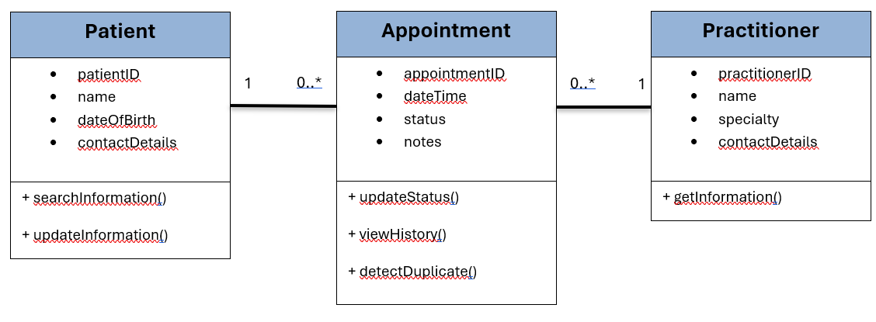

Design Rationale
Explain class selection, responsibility allocation and key relationships.
Patient, Practitioner and Appointment were selected as the main classes since they are the concepts most clearly supported by the SmartCare v0.2 functional requirements. Patient is responsible for patient information and the related search/update behaviour. Practitioner stores practitioner information. Appointment contains the appointment information and status and takes responsibility for status changes, history and duplicate detection.
Patient and Practitioner are both associated with Appointment because the confirmed requirements centre the system around patient, practitioner and appointment information. I did not add a direct Patient-Practitioner relationship because it was not required by the confirmed requirements. Extra ideas such as Status or Manager classes were also left out as separate classes because they would make the model more complicated without adding a clearly required domain concept.

AI Design Review Record
AI suggestion | Evidence | Decision | Reason | Model change
Keep Patient, Practitioner and Appointment as the core domain classes. | FR-01 to FR-10 | Accepted | They are directly supported by the confirmed requirements and each has its own information or responsibilities. | No major change; all three remain in the model.
Keep Patient-Appointment and Practitioner-Appointment associations. | FR-03, FR-08 and appointment requirements. | Accepted | The associations give a simple way to connect the three core concepts without inventing a direct Patient-Practitioner relationship. | Associations kept in the UML with multiplicities.
Add a PatientManager class. | FR-01, FR-02, FR-10 | Modified | The behaviour is supported, but a separate manager class would make the model more complicated than needed. | No PatientManager added; responsibilities stay with Patient/main logic.
Add a PractitionerManager class. | FR-08 | Modified | Practitioner information is required, but one requirement does not justify a separate manager class. | No PractitionerManager added.
Add an AppointmentManager class. | FR-03, FR-05, FR-06, FR-07, FR-09 | Modified | Several appointment behaviours are supported, but they can remain with Appointment or the main program logic for now. | No AppointmentManager added.
Add an AppointmentHistory class. | FR-06, FR-07 | Rejected | History required, but the requirements do not show that it needs a separate identity or responsibilities. | History stays with Appointment.
Add a Status class. | FR-05, FR-09 | Rejected | Status is required, but it is simpler and more appropriate as an attribute of Appointment. | Status remains an Appointment attribute.
Add a Duplicate booking checker class. | FR-04 | Rejected | Duplicate detection is required, but a separate class for one behaviour would over-design the current model. | Duplicate detection remains Appointment-related behaviour.

